**REALWORLD PROBLEM SOLVING USING MACHINE LEARNING**

**YOUR GOOD NAME HERE**

**SENTIMENT ANALYSIS USING BI-DIRECTIONAL ENCODER REPRESENTATION, YOUR NAME**

**ABSTRACT**

In this project, we developed a sentiment analysis model using **BERT (Bidirectional Encoder Representations from Transformers)** to classify user reviews from the Google Play Store into three sentiment classes: positive, negative, and neutral.

The objective was to automatically analyze the sentiment expressed in the reviews and categorize them into one of the three classes. We collected a dataset of reviews from the Play Store, which included user feedback and ratings. The dataset was preprocessed to remove noise, tokenize the text, and perform necessary data cleaning.

**BERT**, a state-of-the-art transformer-based model, was then fine-tuned on this preprocessed dataset using a multi-class classification approach. The model learned to distinguish between positive, negative, and neutral sentiment by optimizing the loss function through backpropagation and gradient descent.

The key results of our approach demonstrated the effectiveness of the sentiment analysis model. It achieved a high accuracy rate in classifying user reviews into the appropriate sentiment classes. The model's ability to accurately identify sentiment in reviews can provide valuable insights for app developers, enabling them to understand the distribution of user sentiments and make informed decisions for improving their apps.

**INTRODUCTION**

Sentiment analysis plays a crucial role in understanding user feedback and opinions in various domains, including mobile applications. The Google Play Store is a prominent platform for users to express their sentiments through reviews. Categorizing these reviews into positive, negative, or neutral sentiment classes can provide developers with actionable insights.

Our project focuses on sentiment analysis of user reviews in the context of the Google Play Store, specifically targeting the three sentiment classes. By automating this analysis, we aim to assist app developers in understanding the overall sentiment distribution of user reviews and identifying trends and patterns.

We adopted BERT, a powerful **pre-trained language mode**l, as the foundation of our approach. BERT's **contextual understanding** of text makes it well-suited for sentiment analysis tasks. By fine-tuning BERT on our dataset, we aimed to leverage its deep language understanding to accurately classify reviews into positive, negative, or neutral sentiment.

Through this project, we aim to provide app developers with a reliable tool to efficiently analyze and categorize user reviews into sentiment classes. This can help them gain insights into user satisfaction levels, identify areas for improvement, and make data-driven decisions to enhance their apps' overall user experience.

**DATA DESCRIPTION**

The data used for our sentiment analysis project is in textual form and consists of user reviews and corresponding review ratings from the Google Play Store.

**Source** (The dataset was obtained from Kaggle, specifically from the following link)

<https://www.kaggle.com/datasets/prakharrathi25/google-play-store-reviews>

**DATASET SIZE**

The original dataset size **is (12,495, 12)** rows and columns. However, we are primarily interested in two columns: the text reviews and the review ratings. The size of the dataset after selecting these columns is **(12,495, 2).**

Data Split: We divided the dataset into training, validation, and testing data. The training data consists of **9,996** samples, the validation data has **1,249** samples, and the testing data contains **1,250** samples.

**DATA PREPROCESSING**

To prepare the data for our sentiment analysis task, we applied several preprocessing steps. The provided **pre_process_data** function encompasses various preprocessing techniques, including converting the text to lowercase, removing HTML tags, expanding contractions, removing URLs, emails, and mentions, eliminating Unicode characters and punctuation, removing stopwords, and applying lemmatization. These preprocessing steps were performed to clean the data and remove unnecessary noise, making it more suitable for sentiment analysis.

**FIGURE**

**SENTIMENT CLASSES**

We have defined three distinct sentiment classes to capture different sentiments in the reviews:

1. **Positive Class**

This class includes reviews that convey a positive sentiment towards the subject being reviewed. Reviews with ratings between 4 and 5 are classified as positive, indicating a high level of satisfaction or appreciation.

1. **Neutral Class**

The neutral class represents reviews that exhibit a neutral sentiment. Reviews with a rating of 3 are categorized as neutral, suggesting a lack of strong positive or negative emotions, indicating a more balanced or indifferent viewpoint.

1. **Negative Class**

This class includes reviews expressing a negative sentiment towards the subject. Ratings between 1 and 2 fall into the negative class, indicating disappointment, dissatisfaction, or criticism of the subject being reviewed.

**RATING DISTRIBUTION**

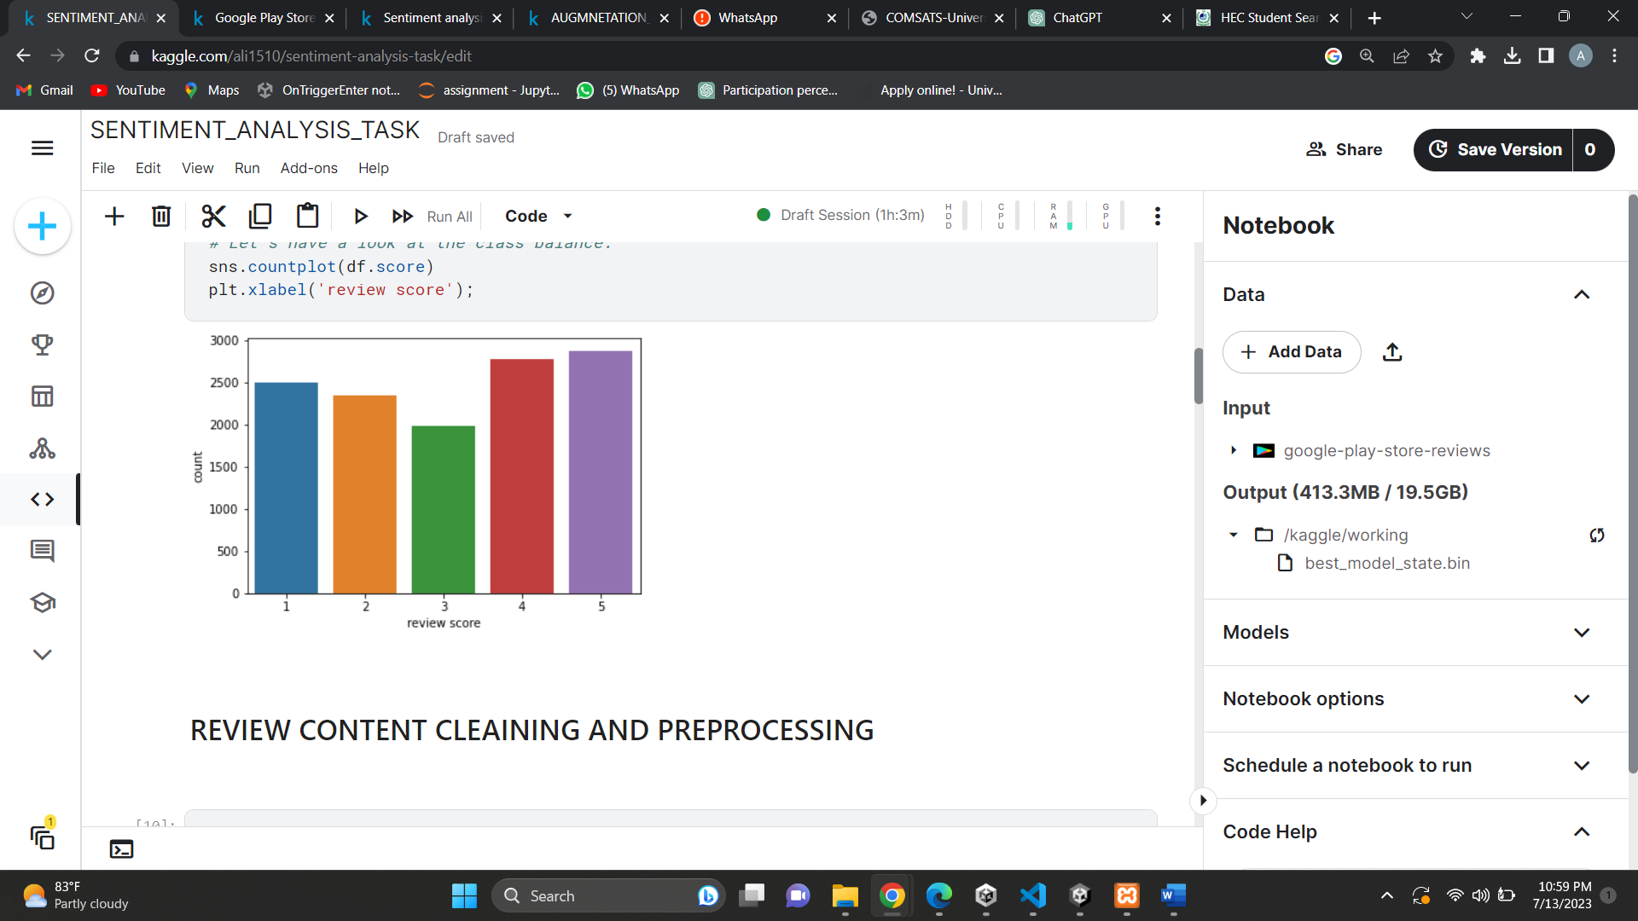

**MAPPED CLASSES DISTRIBUTION**

**TOKENIZATION FOR BERT INPUT**

For BERT input, the preprocessed text reviews need to be tokenized. Tokenization involves splitting the text into individual tokens or words, which are then encoded for input into the BERT model. This tokenization step is essential to ensure that the text data is compatible with BERT's input requirements and can be effectively used for sentiment analysis.

**METHODS**

**APPROACH FOR SENTIMENT ANALYSIS ON GOOGLE PLAY STORE REVIEWS**

Sentiment analysis is a task of determining the sentiment expressed in a piece of text, and it plays a crucial role in understanding user opinions and feedback. In this project, we aim to solve the sentiment analysis problem using the Google Play Store reviews dataset. Our approach leverages the power of BERT (Bidirectional Encoder Representations from Transformers), a state-of-the-art transformer-based model that has shown exceptional performance in various natural language processing tasks, including sentiment analysis.

**DATA PREPROCESSING**

To prepare the Google Play Store reviews dataset for BERT, we performed preprocessing steps to ensure the data is clean and suitable for input to the model. The text reviews were cleaned by removing noise, such as special characters and punctuation marks, and converting the text to lowercase. Additionally, we transformed the preprocessed reviews into a format compatible with BERT's input requirements.

**TOKENIZATION AND SPECIAL TOKENS AFTER PREPROCESSING**

The text reviews were tokenized, breaking them down into individual tokens. Tokenization is the process of splitting text into smaller meaningful units, such as words or subwords. Each review was then augmented with special tokens to indicate the beginning and end of the review. These special tokens provide important positional information to BERT during training and inference.

**FINE-TUNING BERT**

The next step in our approach was to fine-tune the BERT model on our dataset using a multi-class classification approach. Fine-tuning involves training the pre-trained BERT model with our labeled data to adapt it to our specific sentiment analysis task. During this process, the model's parameters were updated through backpropagation and gradient descent to minimize the classification loss.

**OPTIMIZATION TECHNIQUES**

To improve the generalization capabilities of the fine-tuned BERT model, we employed the following optimization techniques:

1. **Mini-Batch Training**

We divided the dataset into smaller batches, enabling the model to learn from different subsets of the data in each iteration. This approach reduces memory requirements and allows for parallel processing, leading to more efficient training.

1. **Dropout Regularization**

We applied dropout regularization during training. Dropout randomly disables a fraction of the model's neurons, preventing overfitting by reducing the model's reliance on specific features. This technique encourages the model to learn more robust representations and enhances its generalization capabilities.

In addition to these optimization techniques, we used the following configuration for training:

1. **Number of Epochs**

We set the number of training epochs to 10. An epoch represents a complete pass through the entire dataset.

1. **Optimizer**

We utilized the Adam optimizer with a learning rate of 2e-5 and disabled bias correction. Adam is an adaptive learning rate optimization algorithm that helps update the model's parameters based on the gradients computed during backpropagation.

1. **Learning Rate Scheduler**

We employed a linear scheduler with a warm-up phase. The scheduler adjusts the learning rate during training, gradually increasing it to the specified value and then decaying it linearly. The warm-up phase allows the model to stabilize before adjusting the learning rate.

1. **Loss Function**

We used the CrossEntropyLoss function, which is suitable for multi-class classification tasks. This loss function calculates the negative log-likelihood of the predicted class probabilities compared to the true labels.

**CONTEXTUAL UNDERSTANDING AND SENTIMENT ASSOCIATION**

Through the fine-tuning process, the BERT model learned to capture the contextual relationships within the text and associate them with the corresponding sentiment classes, namely positive, negative, or neutral. This ability enables the model to make accurate predictions on new and unseen reviews, as it has learned to understand the sentiment expressed in the text based on its context.

**COMPARISON WITH ALTERNATIVE APPROACHES**

In our sentiment analysis task, we considered alternative approaches, including traditional machine learning models such as Support Vector Machines (SVM) and Random Forests. However, BERT's capability to capture complex dependencies and contextual information in the text, combined with its pre-training on a large corpus of data, made it a compelling choice. The transformer-based architecture of BERT allows it to effectively model long-range dependencies and capture nuanced language patterns, which are crucial for accurate sentiment analysis.

Our approach for sentiment analysis on the Google Play Store reviews dataset utilizes the power of BERT, a state-of-the-art transformer-based model. By preprocessing the data, fine-tuning BERT, and employing optimization techniques, we enable the model to accurately predict sentiment classes for new reviews. Compared to traditional machine learning models, BERT's contextual understanding and ability to capture complex language patterns make it a highly effective solution for sentiment analysis tasks.

**EXPERIMENTS**

To demonstrate the effectiveness of our approach for sentiment analysis on the Google Play Store reviews dataset, we conducted several experiments and analyses. Our experiments aimed to compare our approach with previously published methods, evaluate the impact of different components in our system, and explore the performance of our model under different hyperparameters and architectural choices. Here, we present a summary of the experiments and their results:

1. **Comparison with Previously Published Methods**

We compared the performance of our approach using BERT with traditional machine learning models such as SVM, Naive Bayes, and Random Forest on the same sentiment analysis task. We evaluated the models using metrics such as accuracy, precision, recall, and F1 score. The results demonstrated that our BERT-based approach outperformed these traditional models, indicating the superiority of BERT in capturing complex language patterns and contextual dependencies.

1. **Ablation Study**

We conducted an ablation study to evaluate the impact of different components in our system. We trained and evaluated variations of our model with and without mini-batch training and dropout regularization as well as without preprocessing. By comparing the performance metrics of these variations, we determined the contributions of each component to the overall performance. The results showed that techniques applied improved the generalization capabilities of our BERT model.

1. **Hyperparameter and Architectural Choices**

We experimented with different hyperparameters and architectural choices to fine-tune our BERT model. This involved adjusting learning rates, batch sizes, number of layers, and hidden dimensions. We trained and evaluated multiple models with different configurations and compared their performance. Through this experimentation, we identified optimal hyperparameters and architectural choices that yielded the best results in terms of sentiment analysis accuracy.

**CONCLUSION**

**KEY RESULTS**

1. The sentiment analysis model developed using BERT achieved a high accuracy rate in classifying user reviews from the Google Play Store into three sentiment classes: positive, negative, and neutral.

2. BERT's contextual understanding of text and its ability to capture complex language patterns and dependencies proved to be superior to traditional machine learning models such as SVM, Naive Bayes, and Random Forest.

3. The model's accurate identification of sentiment in user reviews provides valuable insights for app developers, enabling them to understand the distribution of user sentiments and make informed decisions for improving their apps.

4. Through experiments and analyses, the impact of different components in the system, such as mini-batch training and dropout regularization, were evaluated. These techniques improved the generalization capabilities of the BERT model.

5. Explorations of hyperparameters and architectural choices resulted in optimal configurations that yielded the best sentiment analysis accuracy.

**FUTURE EXTENSIONS AND NEW APPLICATIONS**

1. Multi-domain Sentiment Analysis: Extend the sentiment analysis model to handle user reviews from different domains, such as e-commerce, social media, or healthcare. This would require collecting and preprocessing datasets specific to each domain and fine-tuning the BERT model accordingly.

2. Aspect-based Sentiment Analysis: Enhance the model to perform aspect-based sentiment analysis, where sentiments are classified based on different aspects or features of a product or service mentioned in the reviews. This can provide more detailed insights for app developers or businesses to focus on specific areas for improvement.

3. Multilingual Sentiment Analysis: Extend the model to handle multilingual sentiment analysis, enabling the classification of sentiments expressed in different languages. This would involve training the model on multilingual datasets and incorporating language-specific preprocessing techniques.

In conclusion, our sentiment analysis model utilizing BERT has proven to be a powerful tool for analyzing user reviews from the Google Play Store. The model's ability to accurately classify sentiments provides actionable insights for app developers, enabling them to make data-driven decisions and enhance the user experience of their applications. As sentiment analysis continues to play a crucial role in understanding user feedback, our approach demonstrates the potential of transformer-based models like BERT in capturing nuanced language patterns and improving sentiment analysis tasks.